## SOFTWARE QUALITY ASSURANCE MANAGEMENT

## NAME:S.Logitha

## REG NO:192121138

**14.USING RAPTOR – DISPLAY POSITION OF NUMBER**

**FLOWCHART**

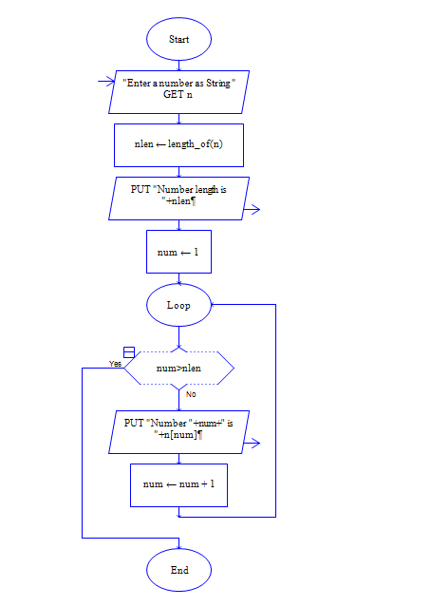

**OUTPUT**

INPUT IS VISHNU079

